Promoted for and on behalf of Cycling Time Trials under their Rules and Regulations

Emergency Services National M254
Individual Time Trial
26/09/2021
First rider off at 08:31

HQ Time Keepers
Kirkley Café Start- Ray Luckett
Thorneyford Farm Finish- Sharon Dyson
Newcastle Upon Tyne
NE20 0AJ

Event Organiser
Terry Wilkinson
27 Hartington Road
Cullercoats
Tyne and Wear
NE30 3SB
07769152563
Tesmacpop@gmail.com

Course description and rider notes

Start 1 mile north of Ponteland on the A696 100 yds north of Dissington Lane End. Proceed via Belsay (Riders take CARE) to Kirkwhelpington on the A696. TURN by turning right into minor road to make safe U turn in minor road (Riders take CARE) and proceed south via Belsay (Riders take CARE) to finish 2 miles north of Ponteland at the old (blocked) gate to Cold Coats Moor farm.

- Be aware of pot holes on the course. The larger ones will be marked up with yellow paint.
- It is the riders responsibility to know the course and route
- The marshals are there for rider safety and are not obliged to wave riders out of junctions. Riders must take due care to make sure it is safe to proceed at junctions on course. This is not a closed road event so be aware of all traffic.
- A detailed map of the course will be available at sign on but please make sure you are aware of the course beforehand.

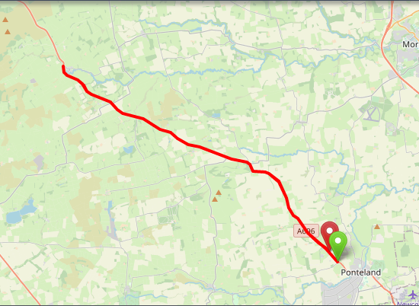

Riding to the start line
Please be aware that the start line is located approx. 5 miles from the HQ so give yourself plenty of time to ride up. Below is a detailed map of how to get to the start line but please take the time to familiarise yourself with the route.
HQ

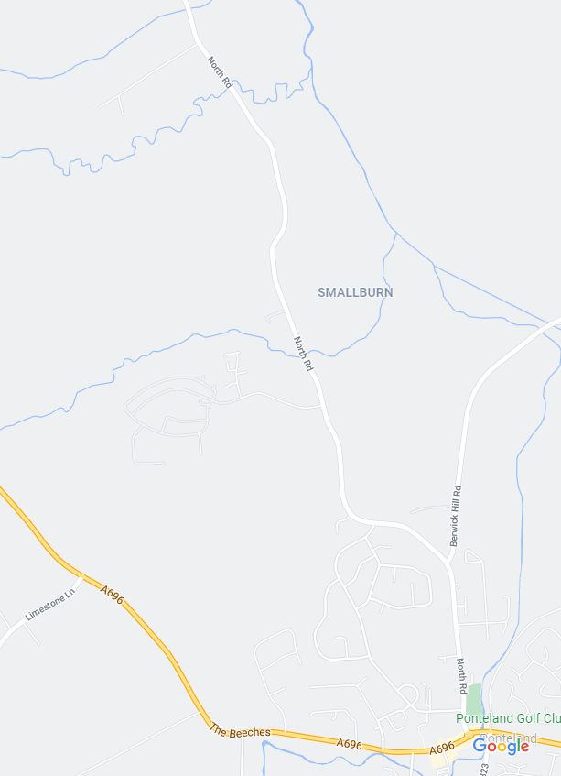
- Turn right out of HQ
- Follow road all the way to Ponteland
- At roundabout, take the second exit and follow road on
- Waitrose should be on your left as you follow road.
- Keep Following road staying on the A696
- The start line is located just beyond the Limestone Lane JCT
- Remember to give yourself at AT LEAST 15 MINUTES to get to the start line
Follow road to start
Waitrose located here

Start Line
Follow this road all the way to Ponteland

At this roundabout, take the second exit onto the A696

Waitrose on left
Follow A696 to start line
Rider’s info for sign on and racing
- Sign on will be available from 07:30am.
- Please bring your own covid friendly pen for signing on and off
- If you have any signs or symptoms of Covid- Cough, high temp, loss of taste or smell, please do not risk turning up. Please withdraw from the event.
- Temperature checks will be taken at sign on.
- Alcohol gel and antibacterial wipes will be available at sign on
- Toilets will be available but please try and get changed before the event where possible.
- Please bring your own safety pins for numbers
- The numbers are disposable but please remember to sign off
- It is compulsory for ALL riders to have a working rear red light for the event. No light, no ride
- Please do not warm up near the start or finish line.
- There is plenty of parking for riders on the day. Please be considerate as there may be local cyclists using the café and its facilities on the day.
- Make sure your number is correctly sighted for the time keepers. Incorrect sighting of the number may result in a DQ.
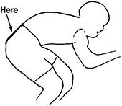

Rider Start Times
NUMBER | RIDER | TEAM | TIME OFF
31 | Al Heatley | Tyne & Wear Fire & Rescue Service CC | 08:31
32 | Ian Watson | Metropolitan Police Cycle Club | 08:32
33 | Esther Hamil | Dumfries CC | 08:33
34 | Natalie Batey | Tyne & Wear Fire & Rescue Service CC | 08:34
35 | Antony Lowe | Team ASL-Bolton | 08:35
36 | Fiona Prew | Stone Wheelers CC | 08:36
37 | Brian O'Neill | GB Fire Service Cycling | 08:37
38 | Graeme Carter | Stockton Wheelers CC | 08:38
39 | Timothy Nuttall | Adept Cycling | 08:39
40 | Graeme Taylor | Tyne & Wear Fire & Rescue Service CC | 08:40
41 | Lee McCarron | Vector Racing | 08:41
42 | Christopher Dursley | Coveryourcar.co.uk RT - Fitted and Tailored Car Covers | 08:42
43 | James Gibney | West Midlands Police CC | 08:43
44 | Paul Armstrong | Team Lifting Gear Products/Cycles In Motion | 08:44
45 | David Linsley | Tyne & Wear Fire & Rescue Service CC | 08:45
46 | Neil Higgins | Team ASL-Bolton | 08:46
47 | Nick Taylor | Metropolitan Police Cycle Club | 08:47
48 | Darren Williamson | Muckle Cycle Club | 08:48
49 | Adam Lowe | Metropolitan Police Cycle Club | 08:49
50 | Paul Shallicker | Coveryourcar.co.uk RT - Fitted and Tailored Car Covers | 08:50
51 | Stewart Burke | Team Andrew Allan Architecture | 08:51
52 | Paul Blackburn | Coveryourcar.co.uk RT - Fitted and Tailored Car Covers | 08:52
53 | Cliff Price | Metropolitan Police Cycle Club | 08:53
54 | Greg Plummer | Springfield Financial Racing Team | 08:54
55 | Terry Wilkinson | Barnesbury CC | 08:55
56 | Mike Dalton | Stockton Wheelers CC | 08:56
57 | William Bonar | GTR - Return To Life | 08:57
58 | Anthony Snow | City RC (Hull) | 08:58
59 | Nev Martin | Velo Culture | 08:59
60 | Tom Clements | Wessex Road Club | 09:00
61 | Chris Smart | GTR - Return To Life | 09:01
62 | Richard Butler | Giant-Kendal RT | 09:02
Kirkley Café
After finishing the race, please sign back in at HQ. When you sign back in, you will be given a £5 voucher which can be spent in the café to buy food or drinks. The presentation will be done once all times are sorted and verified with the time keepers. Please be patient, I will try to get the presentation wrapped up as quickly as possible and prizes handed out as some of you have long journeys home.

